**Exercise 1: Control Structures**

CREATE TABLE Customers (

    CustomerID   NUMBER PRIMARY KEY,

    Name         VARCHAR2(100),

    DOB          DATE,

    Balance      NUMBER(12, 2),

    IsVIP        VARCHAR2(5) DEFAULT 'FALSE'

);

CREATE TABLE Loans (

    LoanID       NUMBER PRIMARY KEY,

    CustomerID   NUMBER REFERENCES Customers(CustomerID),

    InterestRate NUMBER(5, 2),

    DueDate      DATE

);

INSERT INTO Customers VALUES (1, 'John Smith', TO_DATE('1950-05-10','YYYY-MM-DD'), 15000, 'FALSE');

INSERT INTO Customers VALUES (2, 'Alice Green', TO_DATE('1990-03-22','YYYY-MM-DD'), 8500, 'FALSE');

INSERT INTO Customers VALUES (3, 'Robert White', TO_DATE('1945-09-15','YYYY-MM-DD'), 11000, 'FALSE');

INSERT INTO Loans VALUES (101, 1, 5.50, SYSDATE + 15);

INSERT INTO Loans VALUES (102, 2, 6.00, SYSDATE + 40);

INSERT INTO Loans VALUES (103, 3, 5.75, SYSDATE + 5);

**Scenario 1:** The bank wants to apply a discount to loan interest rates for customers above 60 years old.

**CODE:**

BEGIN

    FOR cust_rec IN (SELECT CustomerID, DOB FROM Customers) LOOP

        IF FLOOR(MONTHS_BETWEEN(SYSDATE, cust_rec.DOB) / 12) > 60 THEN

            UPDATE Loans

            SET InterestRate = InterestRate - 0.01

            WHERE CustomerID = cust_rec.CustomerID;

        END IF;

    END LOOP;

    COMMIT;

END;

SELECT * FROM Loans;

**OUTPUT:**

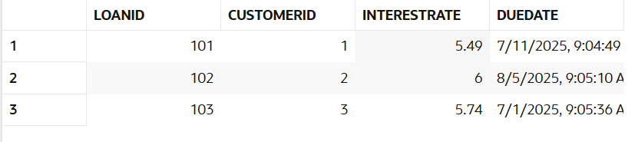

**Scenario 2:** A customer can be promoted to VIP status based on their balance.

**CODE:**

BEGIN

    FOR cust_rec IN (SELECT CustomerID, Balance FROM Customers) LOOP

        IF cust_rec.Balance > 10000 THEN

            UPDATE Customers

            SET IsVIP = 'TRUE'

            WHERE CustomerID = cust_rec.CustomerID;

        END IF;

    END LOOP;

    COMMIT;

END;

SELECT Name, Balance, IsVIP FROM Customers;

**OUTPUT:**

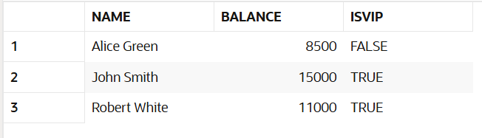

**Scenario 3:** The bank wants to send reminders to customers whose loans are due within the next 30 days.

**CODE:**

BEGIN

FOR loan_rec IN (

SELECT l.LoanID, l.DueDate, c.Name

FROM Loans l

JOIN Customers c ON l.CustomerID = c.CustomerID

WHERE l.DueDate BETWEEN SYSDATE AND SYSDATE + 30

) LOOP

DBMS_OUTPUT.PUT_LINE('Reminder: Loan ID ' || loan_rec.LoanID ||

' for ' || loan_rec.Name ||

' is due on ' || TO_CHAR(loan_rec.DueDate, 'DD-MON-YYYY'));

END LOOP;

END;

**OUTPUT:**

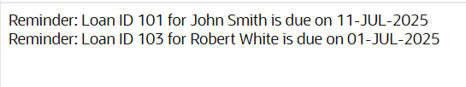

**Exercise 3: Stored Procedures**

CREATE TABLE BankAccounts (

    AccountID     NUMBER PRIMARY KEY,

    CustomerID    NUMBER,

    Balance       NUMBER(12, 2)

);

CREATE TABLE Employees (

    EmpID        NUMBER PRIMARY KEY,

    Name         VARCHAR2(100),

    Department   VARCHAR2(50),

    Salary       NUMBER(10, 2)

);

INSERT INTO BankAccounts VALUES (1001, 201, 10000);

INSERT INTO BankAccounts VALUES (1002, 202, 20000);

INSERT INTO Employees VALUES (1, 'Alice', 'Sales', 50000);

INSERT INTO Employees VALUES (2, 'Bob', 'Sales', 60000);

INSERT INTO Employees VALUES (3, 'Charlie', 'HR', 55000);

**Scenario 1:** The bank needs to process monthly interest for all savings accounts.

**CODE:**

CREATE OR REPLACE PROCEDURE ProcessMonthlyInterest IS

BEGIN

    UPDATE BankAccounts

    SET Balance = Balance + (Balance * 0.01);

    COMMIT;

END;

BEGIN

    ProcessMonthlyInterest;

END;

SELECT * FROM BankAccounts;

**OUTPUT:**

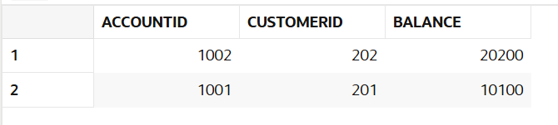

**Scenario 2:** The bank wants to implement a bonus scheme for employees based on their performance.

**CODE:**

CREATE OR REPLACE PROCEDURE UpdateEmployeeBonus(

    p_dept IN VARCHAR2,

    p_bonus_pct IN NUMBER

) IS

BEGIN

    UPDATE Employees

    SET Salary = Salary + (Salary * p_bonus_pct / 100)

    WHERE Department = p_dept;

    COMMIT;

END;

BEGIN

    UpdateEmployeeBonus('Sales', 10);

END;

SELECT * FROM Employees;

**OUTPUT:**

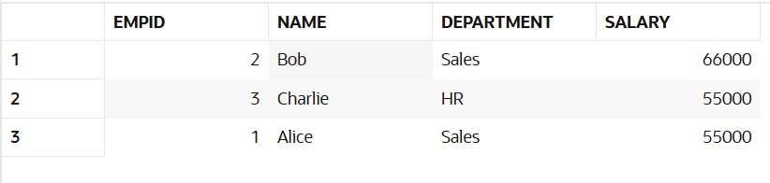

**Scenario 3:** Customers should be able to transfer funds between their accounts.

**CODE:**

CREATE OR REPLACE PROCEDURE TransferFunds(

    p_from_acct IN NUMBER,

    p_to_acct IN NUMBER,

    p_amount IN NUMBER

) IS

    v_balance NUMBER;

BEGIN

    SELECT Balance INTO v_balance

    FROM BankAccounts

    WHERE AccountID = p_from_acct;

    IF v_balance < p_amount THEN

        RAISE_APPLICATION_ERROR(-20001, 'Insufficient balance');

    END IF;

    -- Deduct from source

    UPDATE BankAccounts

    SET Balance = Balance - p_amount

    WHERE AccountID = p_from_acct;

    -- Add to destination

    UPDATE BankAccounts

    SET Balance = Balance + p_amount

    WHERE AccountID = p_to_acct;

    COMMIT;

END;

BEGIN

    TransferFunds(1001, 1002, 2000);

END;

SELECT * FROM BankAccounts;

**OUTPUT:**

